Chapter 10, Solution 67.

Find the Thevenin and Norton equivalent circuits at terminals a-b of the circuit in Fig. 10.110.

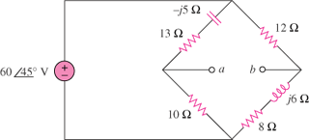

Figure 10.110
For Prob. 10.67.

Solution

V_{Thev} = 4.945∠–69.76° V
I_{N} = 437.8∠–75.24° mA

